Choir Newsletter



Vol. XV, No. 9

Instagram: @bellairehschoir Twitter: @BellaireHSChoir Website: [www.bellairechoir.org](http://www.bellairechoir.org)

Esther Penate 04/08

Angie Simmons 04/12

Kallista Davidson 04/12

Marison Palencia 04/12

Aidan Laughlin 04/18

Kelly Turcios 04/22

Reagan Kimzey 04/26

Tatum Kimbrell 04/26

Julianna Reeves 04/27



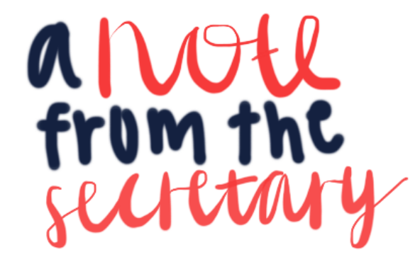

Hi everyone!

I hope you are all staying safe and healthy, getting some exercise outside and spending time with loved ones.

I know this is a time of uncertainty, but please know that your choir family is here for you.

If you need anything at all, do not hesitate to reach out to your choir directors, peers, or officers. We can get through this together!

Lauren





* The choir directors are exploring options with the travel company for cancellation/ rescheduling
* A possibility is to move the NYC trip to spring break 2021, and 2020 seniors will be able to travel with the choir and sing at Carnegie Hall!

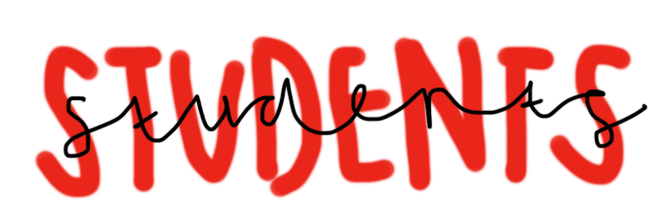

* Make sure you attend your virtual class every other day, and have joined your google classroom
  + A DAY: Chorale Men, Cantamus, Chorale Women
  + B DAY: Belle Voci, Belle Ensemble
* The choir directors have a couple of virtual events in the works, so stay TUNED 😊 in and connected!

Ice cream social 4-6pm

Social

Socials